**Lab 06 - Implement Traffic Management**

**Student lab manual**

Task 1: Creating storage and setting up the resource group and network watcher

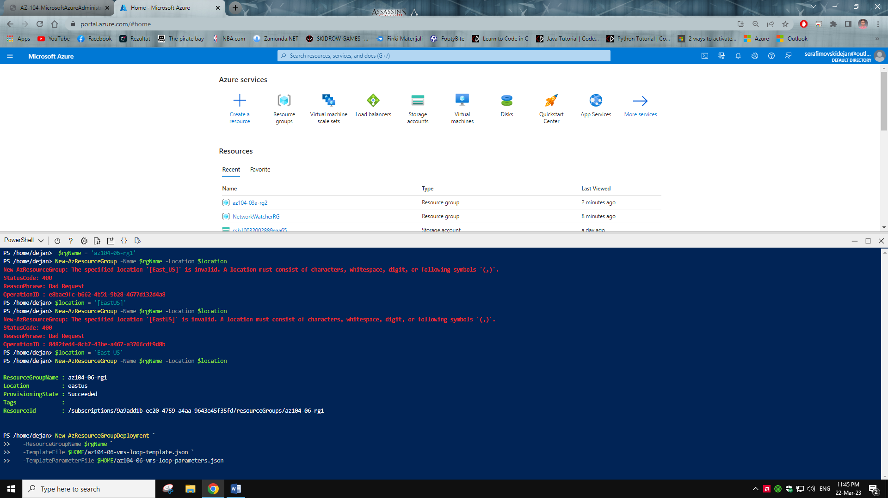

Task 2: Configuring local peering

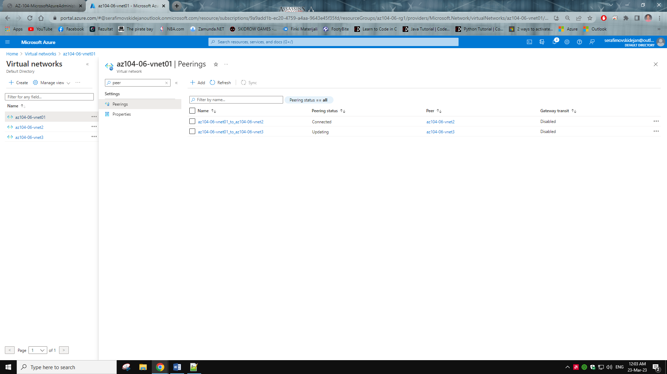

Task 3: Test transitivity of virtual network peering and connection troubleshooting

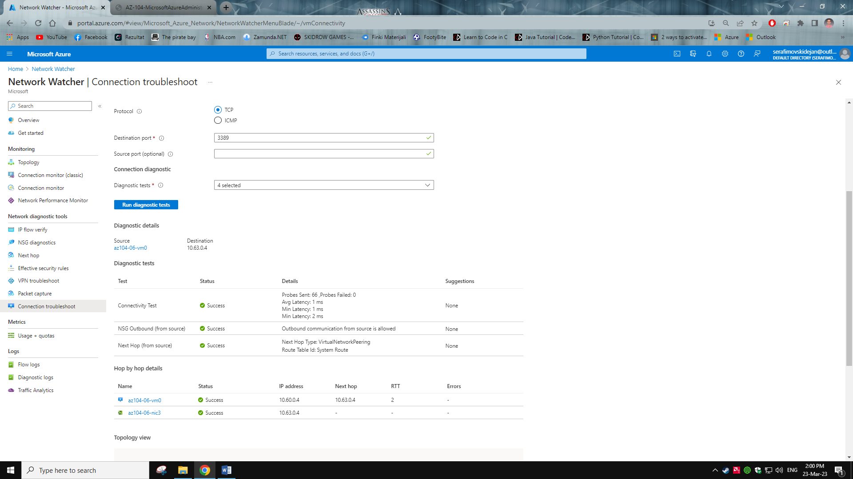

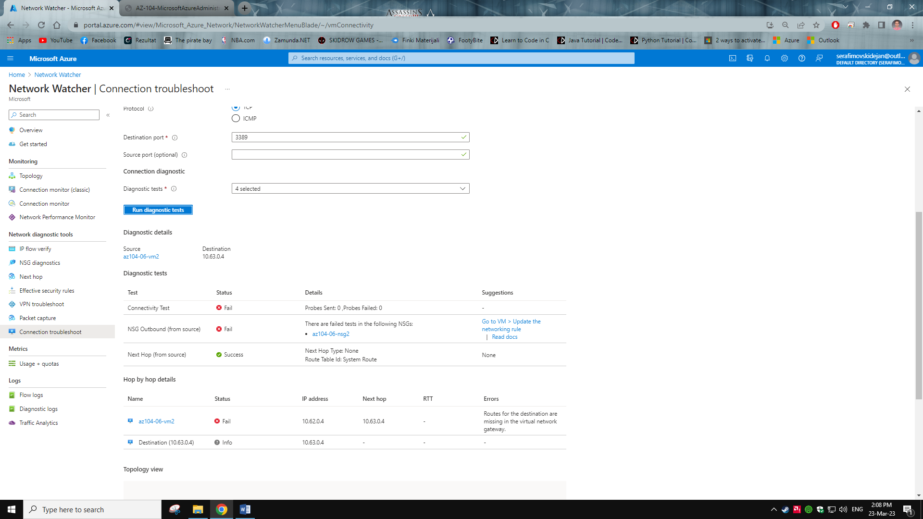

Task 4: Routing traffic and routing tables

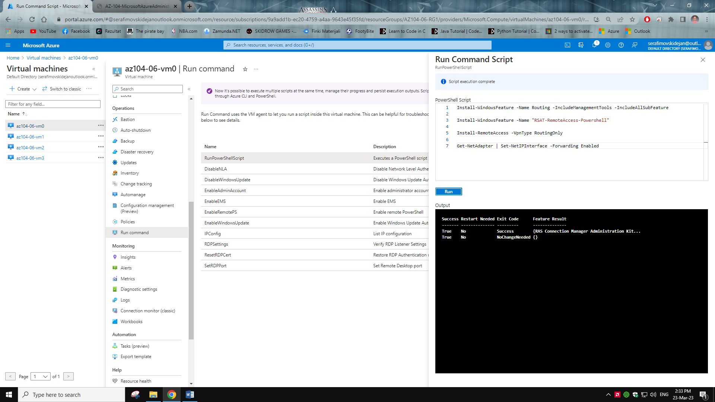

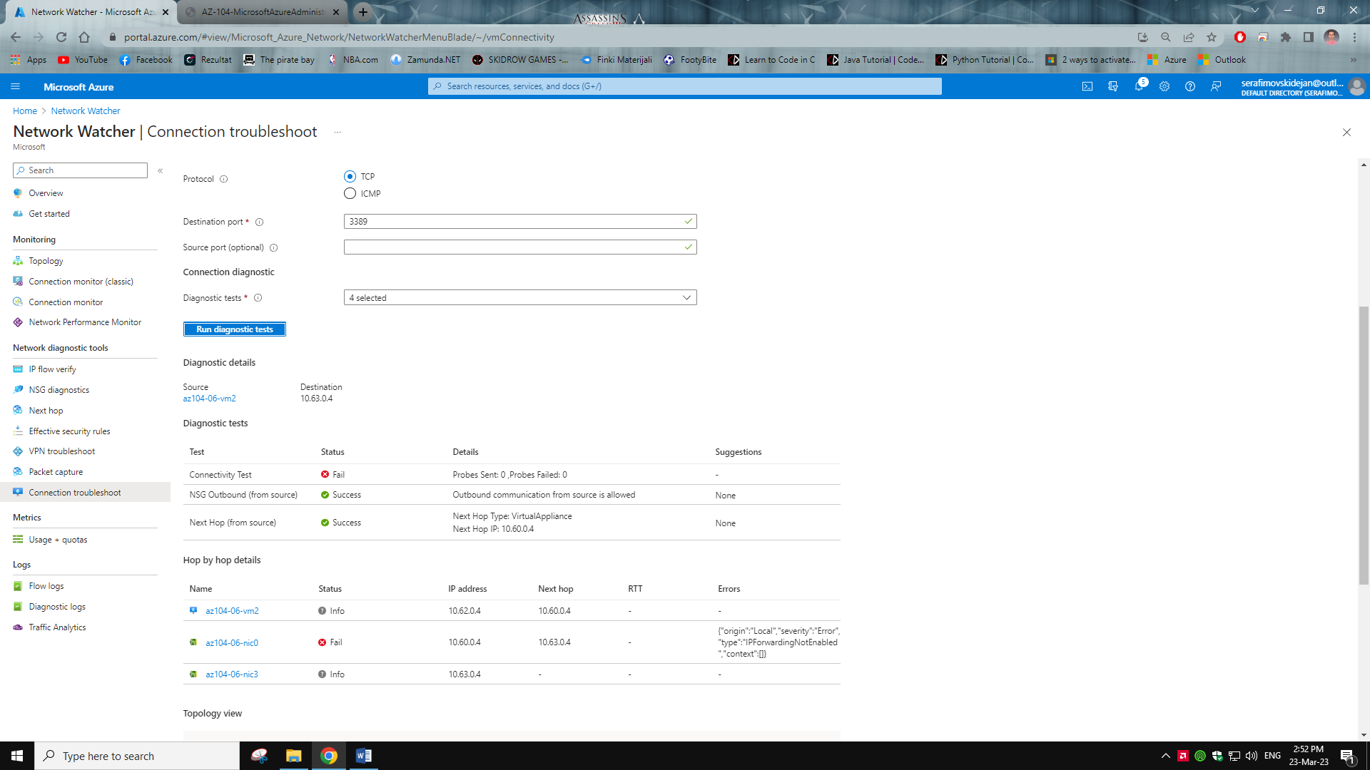

Task 5: Configuring load balancer

Vm0 msg

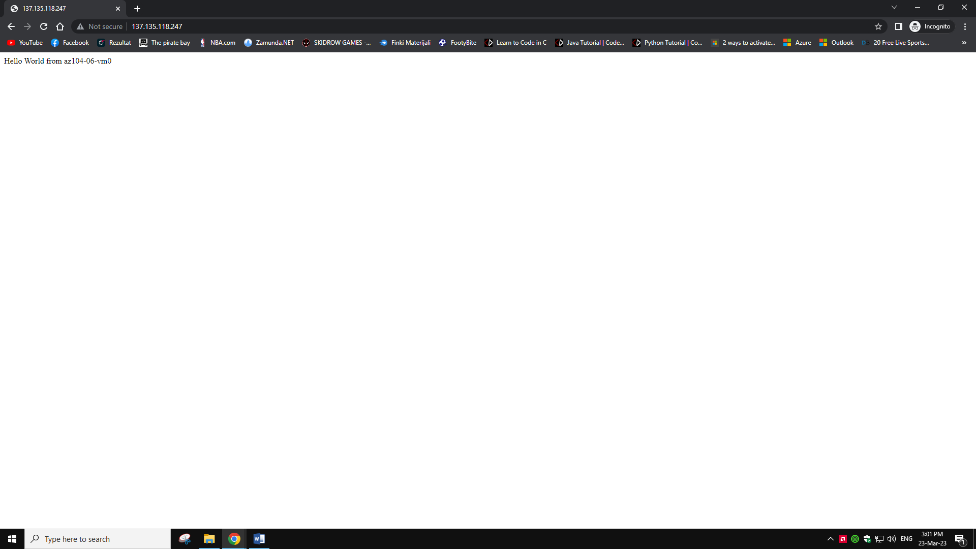

Vm01 msg

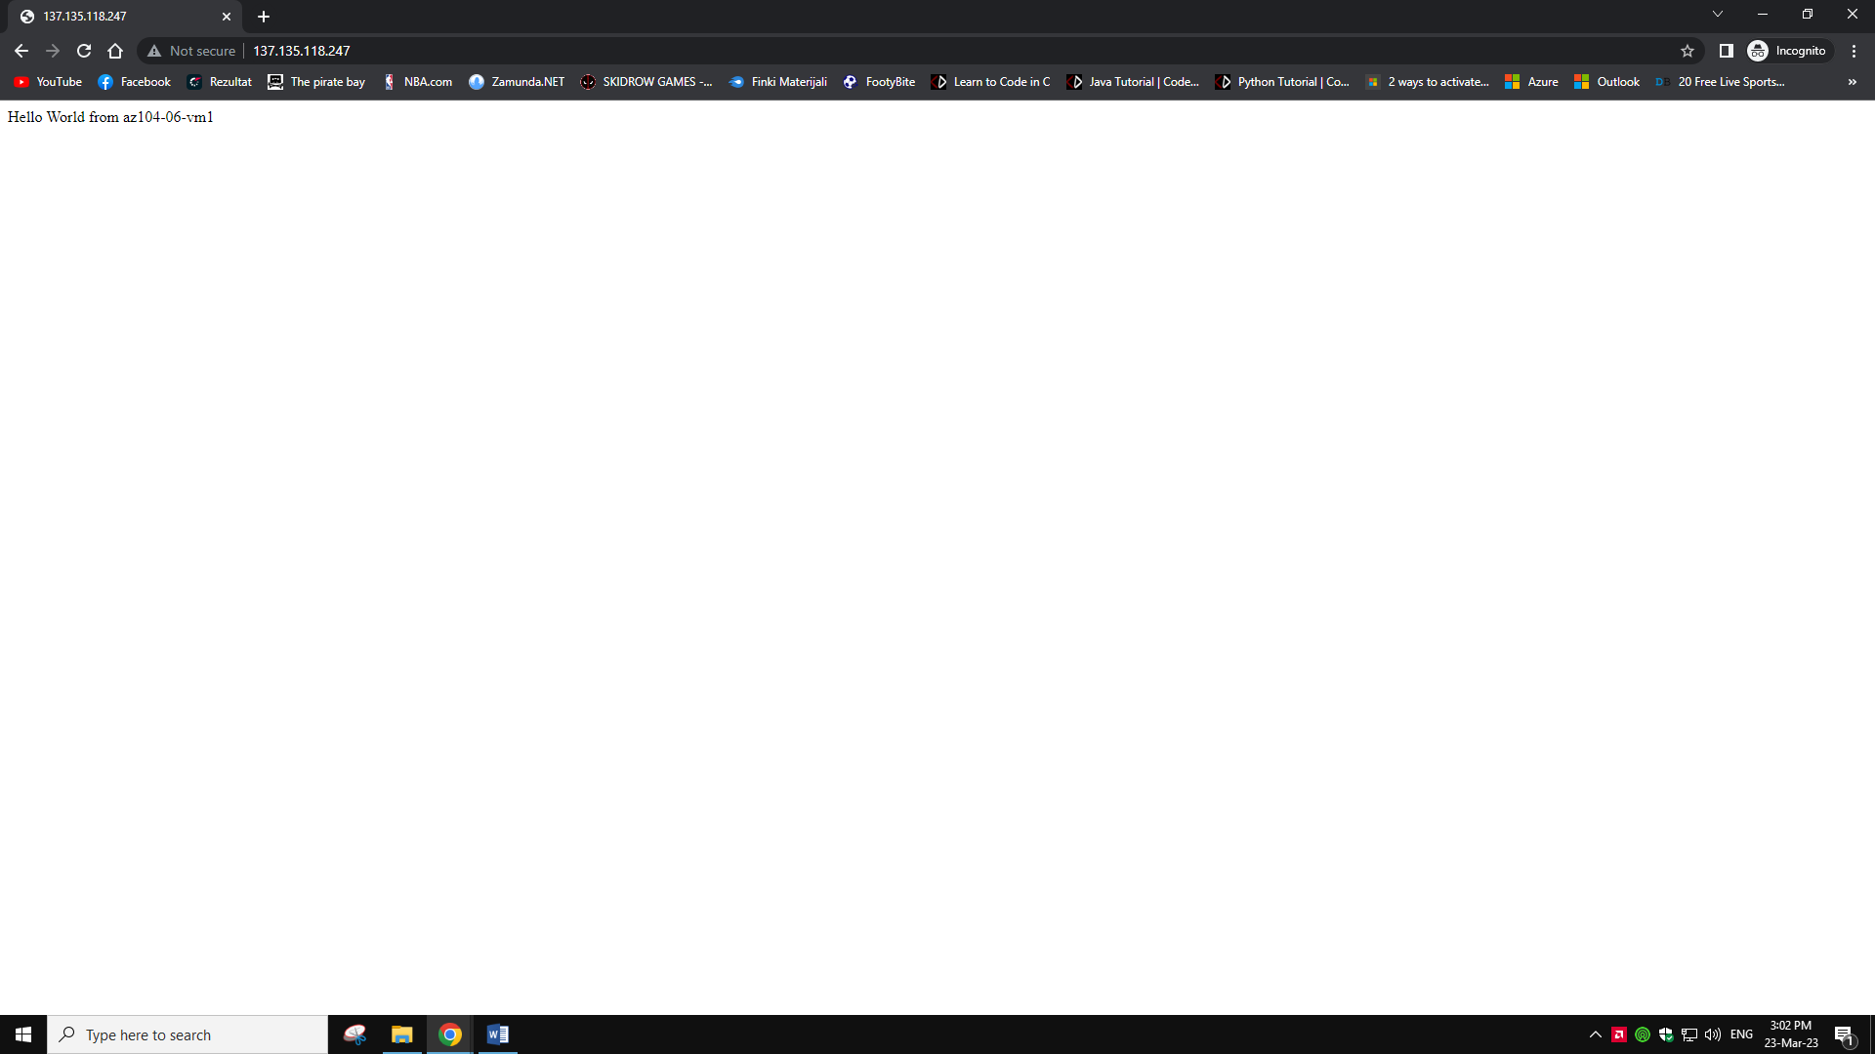

Task 6: Implementing Azure app gateway

Vm2 msg

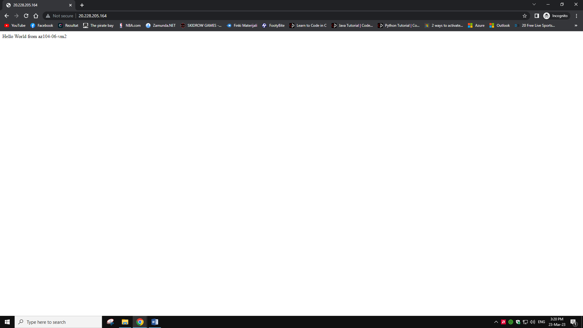

Vm3 msg

